Laboratorio 3

For instance, apply the function uniform_cost_search on r1. What is the cost? 418
report([uniform_cost_search], [r1])

For instance, apply the function breadth_first_search on c2.

What is the number of actions required to solve the problem? 4,333
report([breadth_first_search], [c2])

Now, you can compare the different search algorithms according to the metrics used in the report function.

Plot the results using a bar plot per each metric and per each problem to better compare the different search algorithms.

To do that, for example, you can use matplotlib: https://matplotlib.org/stable/api/_as_gen/matplotlib.pyplot.bar.html
class CountCalls:
"""Delegate all attribute gets to the object, and count them in ._counts"""
def __init__(self, obj):
self._object = obj
self._counts = Counter()

def __getattr__(self, attr):
"Delegate to the original object, after incrementing a counter."
self._counts[attr] += 1
return getattr(self._object, attr)

def report(searchers, problems, verbose=True):
"""Show summary statistics for each searcher (and on each problem unless verbose is false)."""
metrics = [] # ADD We will use a list of dict containing the different metrics
for searcher in searchers:
print(searcher.__name__ + ':')
total_counts = Counter()
for p in problems:
prob = CountCalls(p)
soln = searcher(prob)
counts = prob._counts;
counts.update(actions=len(soln), cost=soln.path_cost)
total_counts += counts
metrics.append(dict(problem_name = str(p)[:40], searcher_name = searcher.__name__ , values = counts)) # ADD to append the different metrics, we can exploit the counts and we can exploit a dictionary to store values
if verbose: report_counts(counts, str(p)[:40])
report_counts(total_counts, 'TOTAL\n')
return metrics

import numpy as np # np is more efficient than using lists in Python

# call the function report
metrics = report([astar_search, greedy_bfs, uniform_cost_search, breadth_first_bfs, breadth_first_search, depth_limited_search], [r0,r1, r2, r3, r4, c0, c1, c2, c3, c4])

# extract the information about the metrics
problems_labels = np.zeros(len(metrics), dtype=object)
searchers_labels = np.zeros(len(metrics), dtype=object)
nodes = np.zeros(len(metrics), dtype=int)
goal = np.zeros(len(metrics), dtype=int)
cost = np.zeros(len(metrics), dtype=int)
actions = np.zeros(len(metrics), dtype=int)

for i, m in enumerate(metrics, 0):
problems_labels[i] = m['problem_name']
searchers_labels[i] = m['searcher_name']
nodes[i] = m['values']['result']
goal[i] = m['values']['is_goal']
cost[i] = m['values']['cost']
actions[i] = m['values']['actions']

# quick check to verify the expected values
print(problems_labels)
print(searchers_labels)
print(nodes)
print(goal)
print(cost)
print(actions)

import matplotlib.pyplot as plt

# function to plot data

def plot_data(data, labels, metric, problem):
fig = plt.figure()
x_pos = np.arange(len(labels))
plt.bar(x_pos, data)
plt.title(metric.upper() + ' ' + problem.upper())
plt.xlabel('Search algorithms')
plt.ylabel( metric + ' count')
plt.xticks(x_pos, labels, rotation=30, ha='right')
plt.show()

# let's divide the data per problem
unique_problems = np.unique(problems_labels)

get_indexes = lambda x, xs: [i for (y, i) in zip(xs, range(len(xs))) if x == y]

for i in range(len(unique_problems)):
indexes = get_indexes(unique_problems[i],problems_labels)
current_searchers_labels = searchers_labels[indexes]
current_nodes = nodes[indexes]
current_goal = goal[indexes]
current_cost = cost[indexes]
current_actions = actions[indexes]

# plot the data
plot_data(current_nodes, current_searchers_labels, 'nodes', unique_problems[i])
plot_data(current_goal, current_searchers_labels, 'goal', unique_problems[i])
plot_data(current_cost, current_searchers_labels, 'cost', unique_problems[i])
plot_data(current_actions, current_searchers_labels, 'actions', unique_problems[i])

Laboratorio 4

dog('Buddy', likes('Buddy', toast)). - This statement is

a.Rule & Horn Clause

b.Not a Horn clause

c.Horn Clause with Head and body

d.Fact & Horn Clause

A prolog query can be made up of only two subgoals.

a. True

b.False

Which one from the options would return true/yes for given prolog program?

boy(john,123).
girl(jane,234).
student(john,123).

a. None of above.

b. ?- girl(jane,x).

c. ?- boy(john,123).

d. All of above.

If sky is blue, everyone likes it. - Write this statement as a prolog clause.

a. likes(X, sky) :- blue(sky).

b. likes(sky, everyone) :- blue(sky).

c. sky(blue) :- everyone(likes).

d. blue(sky), likes(X).

?- owner(jack, cat(X)) :- fur(X),spots(X). - What would be the English meaning for this prolog clause.

a. None of them

b. jack is a owner of cat and fur and spots.

c. jack is the owner of some cat if that cat has fur and spots.

d. jack is the owner of X or jack is the owner of fur and spots .

The following prolog statement is Unifiable?

?- likes(Person, Food) = likes(sam, Food).

a. Vero

b. Falso

For given English statements write a prolog program.
- Facts & Rules
(1) jia is a woman.
(2) john is a man.
(3) john is healthy.
(4) jia is healthy.
(5) john is wealthy.
(6) anyone is a traveler if she/he is healthy and wealthy.
(7) anyone can travel if she/he is a traveler.
- Goals.
(1) Who can travel? john
(2) Who is healthy and wealthy? john

woman(jia).
man(john).

healty(john).
healty(jia).
wealthy(john).

traveler(X):- healty(X),wealthy(X).

can_travel(X) :- traveler(X).

can_travel(X)

healty(X),wealthy(X)

Write a Prolog program that checks if a number is even or odd.

Hint:

X is even if X=0 or the predecessor of X is odd for positive X;

X is odd if the predecessor of X is even for positive X;

X is odd if |X| is odd for negative X;

X is even if |X| is even for negative X.
is_even(0).
is_even(X) :- X > 0, Y is X-1, is_odd(Y).
is_even(X) :- X < 0, is_even(-X).
is_odd(X) :- X > 0, Y is X-1, is_even(Y).
is_odd(X) :- X < 0, is_odd(-X).

Laboratorio 5

Exercise QUIZ

Repeat the third exercise about the Bayesian network (i.e., Sprinkler example)

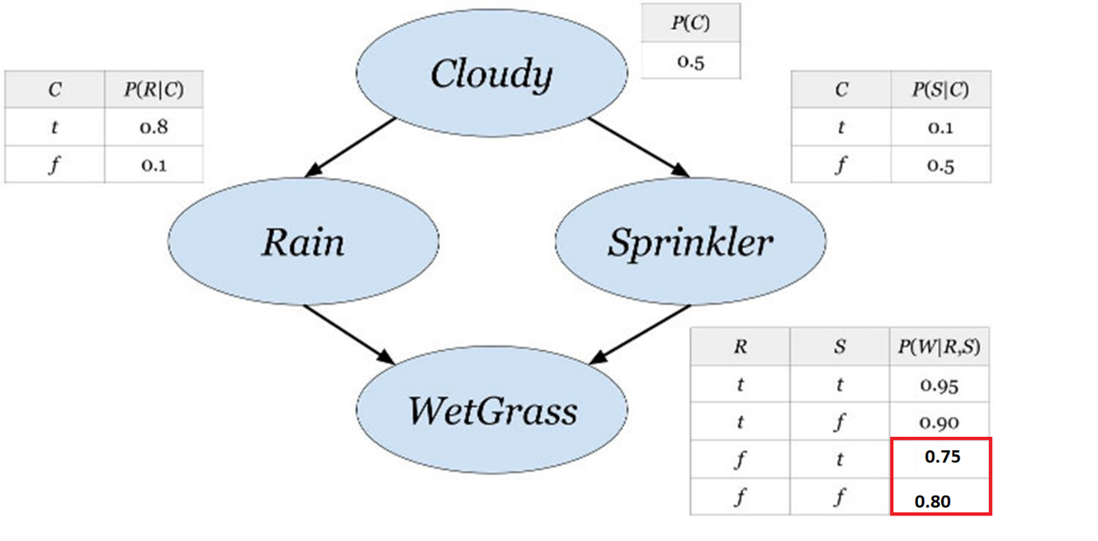

Compute the probability distribution of the wet grass given that is cloudy with the following data (NB: Some values are changed)
import numpy as np

t, f = 0, 1

P_R_C = np.array([[0.8,0.1],[0.2,0.9]])
P_S_C = np.array([[0.1,0.5],[0.9,0.5]])
P_W_RS = np.array([[[0.95, 0.90], [0.75, 0.80]],[[0.05, 0.10], [0.25, 0.20]]])

# Method 1: Direct computation
P_W = (P_W_RS[:,t,t] * P_R_C[t,t] * P_S_C[t,t] + # P(W|r,s)P(r|c)P(s|c)
P_W_RS[:,t,f] * P_R_C[t,t] * P_S_C[f,t] + # P(W|-r,s)P(-r|c)P(s|c)
P_W_RS[:,f,t] * P_R_C[f,t] * P_S_C[t,t] + # P(W|r,-s)P(r|c)P(-s|c)
P_W_RS[:,f,f] * P_R_C[f,t] * P_S_C[f,t]) # P(W|-r,-s)P(-r|c)P(-s|c)
print("P(W) by direct computation:", P_W)

# Method 2: Marginalize one variable at a time
P_W_R = P_W_RS[:,:,t] * P_S_C[t,t] + P_W_RS[:,:,f] * P_S_C[f,t] # P(W|R,s) * P(s|c) + P(W|R,-s) * P(-s|c) = P(W|R)
P_W = P_W_R[:,t] * P_R_C[t,t] + P_W_R[:,f] * P_R_C[f,t]
print("P(W) using intermediate variables:", P_W)

Exercise 1

You are given a (fake) padua_weather.csv of historical records for Padua's weather. The weather, which can be either rainy (= 1 in the dataset), misty (= 2), or sunny (= 3), is reported for each day of the week, for a whole year (52 weeks).

# Preliminary operations
import gdown
import pandas as pd
import numpy as np

#Read the csv file
url = 'https://drive.google.com/uc?id=1LjZLE9ozaHcBwiCl90mHaS1nXKcglfr4'
gdown.download(url, 'padua_weather.csv', quiet=False)

RAINY = 1
MISTY = 2
SUNNY = 3

df = pd.read_csv('padua_weather.csv')
display(df.head())
display(df.map(lambda x: 'Rainy' if x==RAINY else 'Misty' if x==MISTY else 'Sunny' if x==SUNNY else x).head())

In the first extra exercise (Weather's probability), what is the probability of being sunny during the weekend (one or both days)?

# Probability of a sunny weekend
df2 = df.copy()
df2['sunny_weekend'] = ((df2['Saturday'] == SUNNY) | (df2['Sunday'] == SUNNY)).astype(int)
p_sunny = df2['sunny_weekend'].mean()
print(f'Probability of a sunny weekend: {p_sunny*100:.2f}%')

Expected weather for each day of the week (*)
# Expected weather for each day of the week

expected_weather = df.mean()
expected_weather

Supposed you don't know which day of the week is today: although very unrealistic, how could you guess which day is today based only on the weather?

# Count occurrences of weather types per day
weather_weekly_count = df.apply(lambda x: x.value_counts()).fillna(0).astype(int)
display(weather_weekly_count)

# Show probability of days given weather (sorted)
for w in [RAINY, MISTY, SUNNY]:
row = weather_weekly_count.loc[w]
row = row / row.sum()
display(row.sort_values(ascending=False))

# Get the most probable day given the weather
most_likely_day = weather_weekly_count.idxmax(axis=1)
most_likely_day

Exercise 2

The following is a simplified version of an example in Judea Pearl's *The Book of Why*. It refers to a case of cholera epidemic, caused by contaminated water, which killed hundreds of people in London between 1853 and 1854. The diagram below illustrates some of the key factors explaining this epidemic, in particular:

- X indicates whether the water company's intake was downstream of the London's sewers;

- W indicates whether the water was contaminated or not;

- Z indicates the presence of other external factors (e.g. poverty, miasma, etc.);

- Y indicates the outbreak of cholera.

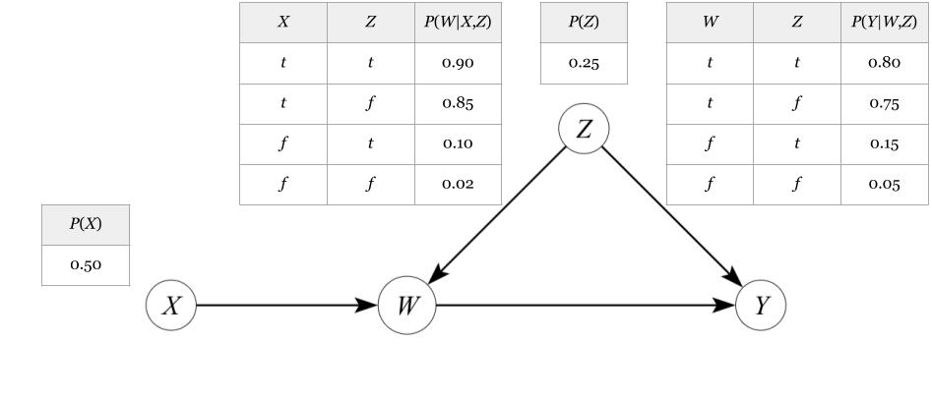Formalise the problem using opportune mathematical notations and derive an expression for computing the probability distribution of the cholera given that the water company's intake is upstream (i.e. what is the query? how can it be decomposed?)
import numpy as np
t,f = 0,1
p_x = [0.5,0.5]
p_z = [0.25,0.75]
p_w_xz = np.array([[[0.90,0.85], [0.10,0.02]],[[0.10,0.15], [0.90,0.98]]])
p_y_wz = np.array([[[0.80,0.75], [0.15,0.05]], [[0.20,0.25], [0.85,0.95]]])

Write a Python program that computes the actual probabilities of the above distribution using the information from the given CPTs.

print('P(W|w,-z)=',p_w_xz[t,t,f]) # P(w|x,-z)
print('P(W|-w,z)=',p_y_wz[t,f,t]) # P(-y|-w,z)

print('P(Y|w, x = false, z = true)= ', p_y_wz[:,t,f]*p_w_xz[t,f,f]+ p_y_wz[:,f,f]*p_w_xz[f,f,f])
print('P(Y|w, x = false, z = true)= ', p_y_wz[:,t,t]*p_w_xz[t,f,t]+ p_y_wz[:,f,t]*p_w_xz[f,f,t])

p_y = p_y_wz[:,t,t] * p_w_xz[t,f,t] * p_z[t] +\
p_y_wz[:,t,f] * p_w_xz[t,f,f] * p_z[f] +\
p_y_wz[:,f,t] * p_w_xz[f,f,t] * p_z[t] +\
p_y_wz[:,f,f] * p_w_xz[f,f,f] * p_z[f]

print(f'p(Y|w,z,x=false) = {p_y}')

Laboratorio 6

Exercise 1

Implement the *Prior Sampling* algorithm to do approximate inference on last week's Burglary network.

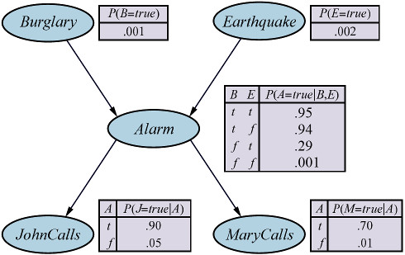

Verify that the algorithm can correctly approximate the probability P(j, m, a, -b, -e) = 0.00063

Try different numbers of samples (e.g. N = 10, 100, 1000, 10000) and compare the results.
# I report the code explained during the lesson below since it is the base for solving the exercise 1
import numpy as np
import random as rnd

t, f = 0, 1

def samplegen(Pdist, Parents = []):
assert len(Parents) < len(Pdist.shape)
if rnd.random() < Pdist[t][tuple(Parents)]:
return t
return f

def parents(X):
return [val[i] for i in par[X]]

# Now Let's define the network using the same structures presented during the lesson

# problem distributions
P_B = np.array([0.001, 0.999])
P_E = np.array([0.002, 0.998])
P_A_BE = np.array([[[0.95, 0.94],[0.29, 0.001]],
[[0.05, 0.06],[0.71, 0.999]]])
P_J_A = np.array([[0.9, 0.05],[0.1, 0.95]])
P_M_A = np.array([[0.7, 0.01],[0.3, 0.99]])

# network variables...
var = ['B','E','A','J','M']
# their distributions...
prd = {'B':P_B, 'E':P_E, 'A':P_A_BE, 'J':P_J_A, 'M':P_M_A}
# their parents...
par = {'B':[],'E':[], 'A':['B','E'], 'J':['A'], 'M':['A']}
# and their initial values
val = {'B':f, 'E':f, 'A':f, 'J':f, 'M':f}

# Given the request to apply prior sampling with different number of samples, I create a function with the code explained during the lesson and with the param
#the number of events
def priorSampling(n_events):
event = []

for n in range(n_events):
for x in var:
val[x] = samplegen(prd[x], parents(x))
event.append(['f' if val[x] else 't' for x in var])

print("Number or randomly generated events = ", len(event))
return event

#Q.1.1 Try different numbers of samples (e.g. $N = 10, 100, 1000, 10000$) and compare the results.
test_values = [10**(i+1) for i in range(6)] #a loop based on the power of 10
for i in range(len(test_values)):
data = priorSampling(test_values[i]) # generate the samples
P_query = data.count(['f', 'f', 't', 't', 't']) / len(data) # we have to compute P(j,m,a,¬b,¬e), pay attention to the order of the variables
print("P(j,m,a,¬b,¬e) = ", P_query)

Exercise 2
from pomegranate import DiscreteDistribution, ConditionalProbabilityTable, Node, BayesianNetwork
Rain0 = DiscreteDistribution({'y': 0.5, 'n': 0.5})

Rain1 = ConditionalProbabilityTable(
[['y', 'y', 0.7],
['y', 'n', 0.3],
['n', 'y', 0.3],
['n', 'n', 0.7]], [Rain0])

Rain2 = ConditionalProbabilityTable(
[['y', 'y', 0.7],
['y', 'n', 0.3],
['n', 'y', 0.3],
['n', 'n', 0.7]], [Rain1])

Umbrella1 = ConditionalProbabilityTable(
[['y', 'y', 0.9],
['y', 'n', 0.1],
['n', 'y', 0.2],
['n', 'n', 0.8]], [Rain1])

Umbrella2 = ConditionalProbabilityTable(
[['y', 'y', 0.9],
['y', 'n', 0.1],
['n', 'y', 0.2],
['n', 'n', 0.8]], [Rain2])

# The whole network has five nodes:
s1 = Node(Rain0, name="Rain0")
s2 = Node(Rain1, name="Rain1")
s3 = Node(Umbrella1, name="Umbrella1")
s4 = Node(Rain2, name="Rain2")
s5 = Node(Umbrella2, name="Umbrella2")
# Create a network that includes nodes and edges between them:
model = BayesianNetwork("Umbrella Network")
model.add_states(s1, s2, s3, s4, s5)
model.add_edge(s1, s2)
model.add_edge(s2, s3)
model.add_edge(s2, s4)
model.add_edge(s4, s5)
# Fix the model structure
model.bake()

Q2.1 Use pomegranate to calculate the filtered probability of rain on Day 2 when we see an umbrella on Day 1 and Day 2.
scenario = [[None, None, 'y', None, 'y']]
results = model.predict_proba(scenario)
print(results[0][3].items())

Q2.1 Use pomegranate to calculate the filtered probability of rain on Day 2 when we see an umbrella on Day 1 and Day 2.
scenario = [[None, None, 'y', None, 'y']]
results = model.predict_proba(scenario)
print(results[0][3].items())

Q2.3 How about if we just have no information about Umbrellas on Day 1 (But we still see the umbrella in Day 2)?
scenario = [[None, None, None, None, 'y’]]
results = model.predict_proba(scenario)
print(results[0][3].items())

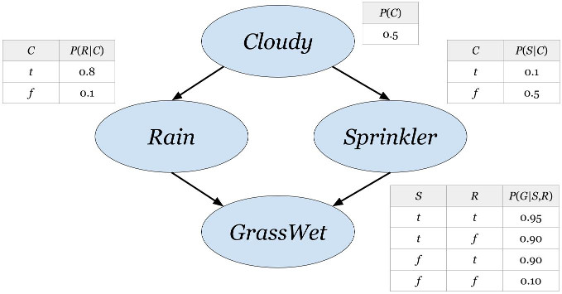
Laboratorio 7

1) Write a Python script that computes P(g|do(r)) seen during the lecture
import numpy as np

t,f = 0,1
p_c = np.array([0.5,0.5])
p_r_c = np.array([[0.8,0.1],[0.2,0.9]])
p_s_c = np.array([[0.1,0.5],[0.9,0.5]])
p_g_rs = np.array([[[0.95,0.90],
[0.90,0.10]],
[[0.05,0.10],
[0.10,0.90]]])

p_g_rs[:,t,t] * p_s_c[t,t] * p_c[t] + \
p_g_rs[:,t,t] * p_s_c[t,f] * p_c[f] + \
p_g_rs[:,t,f] * p_s_c[f,t] * p_c[t] + \
p_g_rs[:,t,f] * p_s_c[f,f] * p_c[f]

2) What is the causal effect of the cloudy weather $c$ on the grass' wetness $g$? (i.e. math expression of $P(g | do(c))$
$C$has no parents, so the graphs pre- and post-intervention are the same. Therefore $P(g | do(c)) = P(g | c)$

3) Between rain and sprinkler, which one has the stronger causal effect on the wetness, $P(g | do(r))$or $P(g | do(s))$ ?
p_g_rs[:,t,t] * p_r_c[t,t] * p_c[t] + \
p_g_rs[:,t,t] * p_r_c[t,f] * p_c[f] + \
p_g_rs[:,f,t] * p_r_c[f,t] * p_c[t] + \
p_g_rs[:,f,t] * p_r_c[f,f] * p_c[f]

4) Compute the average causal effect (ACE) of the sprinkler on the wetness $g$.
p_g_dos = p_g_rs[t,t,t] * p_r_c[t,t] * p_c[t] + \
p_g_rs[t,t,t] * p_r_c[t,f] * p_c[f] + \
p_g_rs[t,f,t] * p_r_c[f,t] * p_c[t] + \
p_g_rs[t,f,t] * p_r_c[f,f] * p_c[f]

p_g_donots = p_g_rs[t,t,f] * p_r_c[t,t] * p_c[t] + \
p_g_rs[t,t,f] * p_r_c[t,f] * p_c[f] + \
p_g_rs[t,f,f] * p_r_c[f,t] * p_c[t] + \
p_g_rs[t,f,f] * p_r_c[f,f] * p_c[f]

ACE = p_g_dos - p_g_donots
ACE

Laboratorio 8

Exercise 1

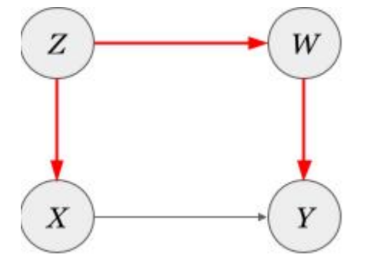

Create the following causal network to verify that the red path is indeed a backdor path using the Causal Graphical Models library
# We create a network object with four nodes and four edges, oriented as in the above graph:
bdnet1 = cgm.CausalGraphicalModel(
nodes = ['X', 'Y', 'Z', 'W'],
edges = [
('X','Y'),
('Z', 'X'),
('Z', 'W'),
('W', 'Y')
]
)

bdnet1.draw()

# To list all the possible backdoor paths between X and Y , we can use the following method:
bdnet1.get_all_backdoor_paths('X', 'Y')

Exercise 2

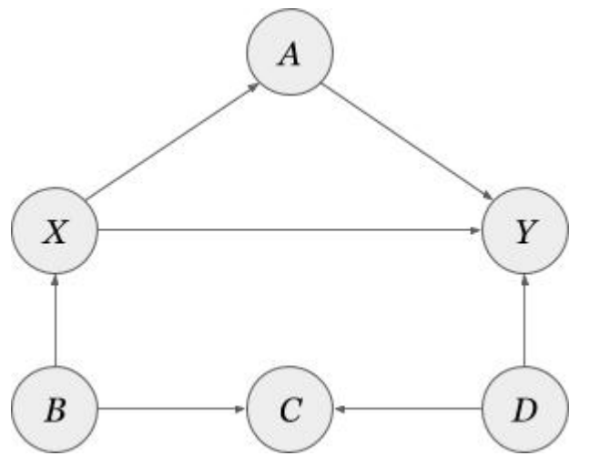

Create the following causal network using the Causal Graphical Models library and find out all the possible sets that satisfy the backdoor criterion.

bdnet2 = cgm.CausalGraphicalModel(
nodes = ['X', 'Y', 'A', 'B', 'C', 'D'],
edges = [
('X','A'), ('A', 'Y'),
('X', 'Y'),
('B', 'X'), ('B', 'C'), ('D', 'C'), ('D', 'Y')
]
)

bdnet2.draw()

# This network has one backdoor path:
bdnet2.get_all_backdoor_paths('X', 'Y')

# We can now ask what are the valid sets satisfying the backdoor criterion:
bdnet2.get_all_backdoor_adjustment_sets('X', 'Y')

# We can also check whether a given set (e.g., {B,C,D}) is valid by using the following method:
bdnet2.is_valid_backdoor_adjustment_set('X', 'Y', {'B', 'C', 'D'})
# and again we confirmed that {B, C, D} is a valid set for backdoor adjustment.

Exercise 3

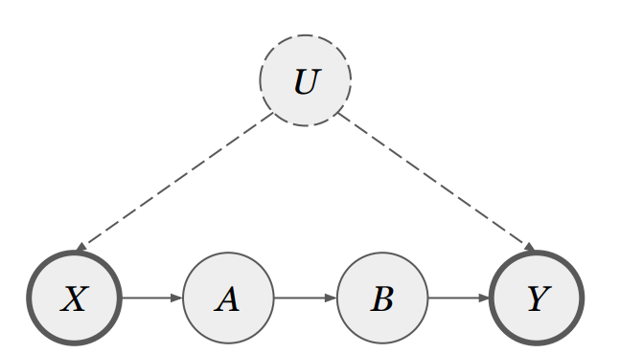

Create the following causal network using the Causal Graphical Models library and find out all the valid sets for applying the front-door criterion.
# PART1
bdnet3 = cgm.CausalGraphicalModel(
nodes = ['X', 'A', 'B', 'Y'],
edges = [
('X','A'),
('A', 'B'),
('B', 'Y'),
],
latent_edges = [
('X', 'Y')
]

)

bdnet3.draw()

# The following method can be used to detect all the valid sets for applying the front-door
# criterion:
bdnet3.get_all_frontdoor_adjustment_sets('X', 'Y')

Exercise 4

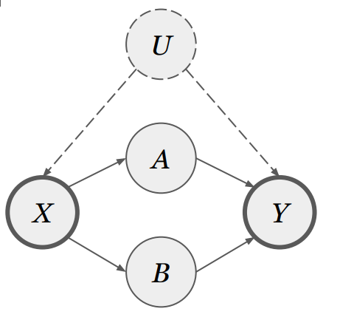

Create the following causal network using the Causal Graphical Models library and find out all the valid sets for applying the front-door criterion.
Bdnet4 = cgm.CausalGraphicalModel(
nodes = ['X', 'Y', 'A', 'B'],
edges = [('X','A'), ('A', 'Y'), ('X', 'B'), ('B', 'Y'),],
latent_edges = [('X', 'Y')]
)
Bdnet4.draw()
Bdnet4.get_all_frontdoor_adjustment_sets('X', 'Y')

Exercise 5

Consider again the smoking example, for which we have the following data from an hypothetical experiment with 400 smokers and 400 non-smokers:

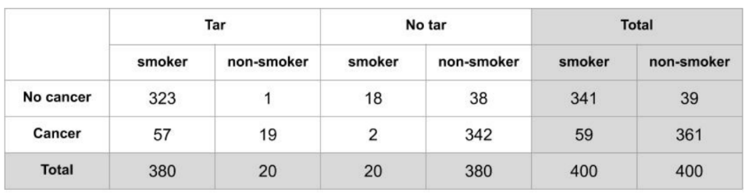

Write a Python program implementing the front-door adjustment and compute the causal effect of smoking on lung cancer is $P(y | do(x))$.
t,f = 0,1

p_s = np.array([0.5,0.5])
p_t_s = np.array([[380/400, 20/400], # tar = true
[20/400, 380/400]]) # tar = false
p_c_ts = np.array([[[57/380,19/20],
[2/20, 342/380]], # cancer = true
[[323/380, 1/20],
[18/20,38/380]]]) # cancer = false

p1 = p_c_ts[t,t,f] * p_s[f] + p_c_ts[t,t,t] * p_s[t]
p2 = p_c_ts[t,f,f] * p_s[f] + p_c_ts[t,f,t] * p_s[t]

p_c_dos = p1 * p_t_s[t,t] + p2 * p_t_s[f,t]
p_c_donots = p1 * p_t_s[t,f] + p2 * p_t_s[f,f]
p_c_dos,p_c_donots,p_c_dos-p_c_donots

print(f'P(Cancer|do(smoke)) = {p_c_dos}')
print(f'P(Cancer|do(not smoke)) = {p_c_donots}')
print(f'Effect of the intervention = {p_c_dos - p_c_donots}')

Laboratorio 9

Esercizio 1

You are travelling and have some time to kill at the aiport. There are three things you could spend your time doing:

You could have a coffee. This has a probability of $0.8$of giving you time to relax with a tasty beverage, and a utility of $10$. It also has a probability of $0.2$ of providing you with a nasty cup from over-roasted beans that annoys you, and outcome with a utility of $-5$.

You could shop for clothes. This has a probability of $0.1$ that you will find a great outfit at a good price, utility$20$. However, it has a probability of $0.9$ that you end up wasting money on over-priced junk, utility $-10$.

You could have a bite to eat. This has a probability of$0.8$ that you find something rather mediocre that prevents you from being too hungry during your flight, utility $2$, and a probability of $0.2$ that you find something filling and tasty, utility $5$.
import numpy as np
p_coffee = np.array([0.8,0.2])
u_coffee = np.array([10,-5])

p_shop = np.array([0.1,0.9])
u_shop = np.array([20,-10])

p_eat = np.array([0.8,0.2])
u_eat = np.array([2,5])

QUESTION 1(a): What should you do if you take the principle of maximum expected utility to be your decision criterion?
eu_coffee = np.sum(p_coffee * u_coffee)
eu_shop = np.sum(p_shop * u_shop)
eu_eat = np.sum(p_eat * u_eat)
# ANSWER: coffee

QUESTION 1(b): What should you do if you take the principle of maximax decision criterion to be your decision criterion?
max_u_coffee= np.max(u_coffee)
max_u_shop = np.max(u_shop)
max_u_eat = np.max(u_eat)
# ANSWER: shop

QUESTION 1(c): What should you do if you take the principle of maximin decision criterion to be your decision criterion?
min_u_coffee= np.min(u_coffee)
min_u_shop = np.min(u_shop )
min_u_eat = np.min(u_eat)
# ANSWER: eat

Esercizio 2

Solving a MDP with MDP toolbox

We have four states and four actions.

The actions are: 0 is Right, 1 is Left, 2 is Up and 3 is Down.

The states are 0, 1, 2, 3, and they are arranged like this:

$2$ $3$

$0$ $1$

The motion model provides:

$0.8$ probability of moving in the direction of the action,

$0.1$ probability of moving in each of the directions perpendicular to that of the action.

So that 2 is Up from 0 and 1 is Right of 0, and so on. The cost of any action (in any state) is $-0.04$.

In case of "infeasible" movements, the agent remains in the current state with probability $0.8+0.1$. Consider the perpendicular directions in any case.

The reward for state $3$ is $1$, and the reward for state $1$ is $-1$, and the agent does not leave those states.

Set discount factor equal to $0.99$.
import numpy as np
import mdptoolbox as mt

# Transition matrix shape: (A,S,S)
# NB: State 1 and State 3 are absorbing. The agent does not leave those states.

# *Right, State 0, the agent can remain in State 0 (p=0.1), it can move from state 0 to state
# 1 with a right action (p=0.8) or it can move to state 2 (p=0.1) -> perpendicular direction

# **Left: it is infeasible moving left so the agent stays in State 0 (p=0.8+0.1), but it can
# move up (p=0.1) since it is a perpendicular direction

transitions = np.array([[[0.1, 0.8, 0.1, 0 ], # Right*
[0, 1, 0, 0 ], # State 1 is absorbing
[0.1, 0, 0.1, 0.8],
[0, 0, 0, 1 ]],# State 3 is absorbing
[[0.9, 0, 0.1, 0 ], # Left**
[0, 1, 0, 0 ], # State 1 is absorbing
[0.1, 0, 0.9, 0 ],
[0, 0, 0, 1 ]], # State 3 is absorbing
[[0.1, 0.1, 0.8, 0 ], # Up
[0, 1, 0, 0 ], # State 1 is absorbing
[0, 0, 0.9, 0.1],
[0, 0, 0, 1 ]], # State 3 is absorbing
[[0.9, 0.1, 0, 0 ], # Down
[0, 1, 0, 0 ], # State 1 is absorbing
[0.8, 0, 0.1, 0.1],
[0, 0, 0, 1 ]]]) # State 3 is absorbing

# The reward array has one set of values for each state. Each is the value of all the actions.
# Here there are four actions, all with the usual cost:
rewards = np.array([[-0.04, -0.04, -0.04, -0.04],
[-1, -1, -1, -1],
[-0.04, -0.04, -0.04, -0.04],
[1, 1, 1, 1]])

discount_factor = 0.99

QUESTION 2(a): What is the policy based on the Value iteration algorithm?
vi = mt.mdp.ValueIteration(transitions, rewards, discount_factor)
#vi.setVerbose()
vi.run()
print("Value Iteration policy:", vi.policy)

QUESTION 2(b): What is the policy based on the Policy iteration algorithm?
pi = mt.mdp.PolicyIteration(transitions, rewards, discount_factor)
#pi.setVerbose()
pi.run()
print("Policy Iteration policy:", pi.policy)

QUESTION 2(c): What is the policy based on the Q-Learning algorithm?
ql = mt.mdp.QLearning(transitions, rewards, discount_factor)
#ql.setVerbose()
ql.run()
print("Q-Learning policy:", ql.policy)
#QL Object has not iter and time attributes

QUESTION 2(d): Look at the setVerbose() function and the time attribute of the MDP objects in MDPToolbox and use them to compare the number of iterations (hint: see the iter attribute) and the CPU time used to come up with a solution (hint: see the time attribute) in the Value iteration algorithm and Policy iteration algorithm resolutions.

print("Value Iteration iterations:", vi.iter)
print("Value Iteration CPU time:", vi.time)

print("Policy Iteration iterations:", pi.iter)
print("Policy Iteration CPU time:", pi.time)

print("Q-Learningiterations:", ql.iter)
print("Q-Learning time:", ql.time)

Laboratorio 10

Esercizio 1

Create a SVM with linear kernel using the scikit-learn library.

Verify the performance with different values of the hyperparameter C using the function [logspace](https://numpy.org/doc/stable/reference/generated/numpy.logspace.html), nel range -20:0:20 (i.e., start=-20, stop = 0, num=20) on digits dataset.

QUESTION 1(a): Check the best configuration of C, using the 3-fold cross-validation on the digits dataset.
from sklearn import svm
import numpy as np
from sklearn.model_selection import GridSearchCV
from sklearn import datasets
import matplotlib.pyplot as plt
import numpy as np

digits_data = datasets.load_digits()

n_samples = len(digits_data.images)
X = digits_data.images.reshape((n_samples, -1))
y = digits_data.target
c_range = np.logspace(-20,0,20)
cv = GridSearchCV(svm.SVC(), param_grid={'C': c_range,'kernel':['linear']}, n_jobs=-1, cv=3)
cv.fit(X, y)
print("Best parameters set found on development set:")
print(cv.best_params_)
best_c = cv.best_params_['C']

QUESTION 1(b): Plot the score achieved in each configuration, by showing the different values for C in the x-axis and CV score in y-axis (mean and standard deviation). Suggestion: Use the log-scale.
import matplotlib.pyplot as plt

means = cv.cv_results_['mean_test_score']
stds = cv.cv_results_['std_test_score']
c_range = [p['C'] for p in cv.cv_results_['params']]

plt.figure()
plt.plot(c_range, means, marker='o')
plt.plot([best_c], [max(means)], marker='o',color='red')
plt.xscale('log')
plt.fill_between(
c_range,
np.array(means) - np.array(stds),
np.array(means) + np.array(stds),
alpha=0.2,
)
plt.ylabel("CV score")
plt.xlabel("Parameter C")
plt.show()

QUESTION 1(c): Train and test the model on the digits dataset with the best configuration found at the previous step
from sklearn import metrics

svc = svm.SVC(**cv.best_params_)
svc.fit(X,y)
print(svc.score(X,y))

Esercizio 2

Load the iris dataset from the dataset available at this [link](https://scikit-learn.org/stable/datasets/toy_dataset.html).
import pandas as pd
import seaborn as sns

iris = datasets.load_iris()
data = iris.data
labels = iris.target

QUESTION 2(a): Verify the properties (number of samples, number of classes, etc.) of the dataset as we did during the lecture with the digit dataset.

print("Data shape: ", data.shape)
classes, counts = np.unique(labels,return_counts=True)
print("Classes: ", classes, "Counts: ", counts)

iris_df = pd.DataFrame(data, columns=iris.feature_names)
iris_df['target'] = labels

sns.pairplot(
iris_df,
hue="target",
diag_kind="kde",
markers=["o", "s", "D"],
)

QUESTION 2(b): Split the dataset in training and test according to the following percentages: 70% - 30%
from sklearn.model_selection import train_test_split
random_seed = 42

X_train, X_test, y_train, y_test = train_test_split(
data, labels, test_size=0.3, random_state=random_seed)

print("Train data shape: ", X_train.shape)
print("Test data shape: ", X_test.shape)

train_classes,train_counts = np.unique(y_train,return_counts=True)
test_classes,test_counts = np.unique(y_test,return_counts=True)
plt.bar(train_classes-0.2,train_counts,width=0.4)
plt.bar(test_classes+0.2,test_counts,width=0.4)
plt.xticks(ticks=train_classes, labels=iris.target_names)
plt.legend(['Train set','Test set'])

QUESTION 2(c): Train a SVM with different kernel (linear, rbf, polinomial) by leaving the default values for the hyperparameters

kernels = ['linear','rbf','poly']
scores = []
models = [svm.SVC(kernel=kernel) for kernel in kernels]
for i,model in enumerate(models):
model.fit(X_train, y_train)
z

QUESTION 2(d): Test the achieved models on the test set
scores = []
preds = []
for i,model in enumerate(models):
y_pred = model.predict(X_test)
preds.append(y_pred)
scores.append((y_pred == y_test).mean())

plt.bar(kernels,scores)
plt.ylabel("CV Accuracy")
plt.ylim(0.8,1)
best_kernel = kernels[np.argmax(scores)]
print("Best kernel: ", best_kernel)

QUESTION 2(e):Represent the performances achieved for each kernel in the form of confusion matrix
from sklearn.metrics import confusion_matrix, ConfusionMatrixDisplay
for kernel,y_pred in zip(kernels,preds):
cm = confusion_matrix(y_test, y_pred)
disp = ConfusionMatrixDisplay(confusion_matrix=cm, display_labels=iris.target_names)
disp.plot(cmap=plt.cm.Blues)
plt.title(f'Confusion Matrix - Kernel: {kernel}')
plt.show()

Laboratorio 11

QUESTION 1(a): DATASET: Load the CIFAR10 (https://keras.io/api/datasets/cifar10/) dataset contains 60,000 color images in 10 classes, with 6,000 images in each class.

You can use the function datasets.cifar10.load_data() to load the dataset after importing the keras dataset with the command: from tensorflow.keras import datasets. Split the dataset in train and test set
from tensorflow.keras import datasets
import keras
from sklearn.model_selection import train_test_split
import matplotlib.pyplot as plt
import numpy as np

class_names = ['airplane','automobile','bird','cat','deer','dog','frog','horse','ship','truck']
(x_train, y_train), (x_test, y_test) = datasets.cifar10.load_data()

# Preprocessing
x_train=x_train/255.0
x_test=x_test/255.0

QUESTION 1(b): Plot some samples in the dataset to visualize the kind of data
plt.figure(figsize=(10, 10))
for i in range(25):
ax = plt.subplot(5, 5, i + 1)
plt.imshow(x_train[i])
plt.title(class_names[(y_train[i][0])])
plt.axis("off")

QUESTION 1(c): Build and compile a CNN model composed with:

Conv2D with 32 filters, kernel size 3X3, activation function relu

MaxPooling 2D with kernel size 2x2

Conv2D with 64 filters kernel size 3X3, activation function relu

MaxPooling 2D with kernel size 2x2

Conv2D with 64 filters kernel size 3X3, activation function relu

Flatten layer

Dense layer with 64 neurons and activation function relu

Final Dense layer for returning 10 classes

adam as optmizer

from keras import models, layers

model = models.Sequential()
model.add(layers.Input(shape=(32, 32, 3)))
model.add(layers.Conv2D(32, (3, 3), 1, activation='relu'))
model.add(layers.MaxPooling2D((2, 2)))
model.add(layers.Conv2D(64, (3, 3), activation='relu'))
model.add(layers.MaxPooling2D((2, 2)))
model.add(layers.Conv2D(64, (3, 3), activation='relu'))
model.add(layers.Flatten())
model.add(layers.Dense(64, activation='relu'))
model.add(layers.Dense(10))

model.summary()

model.compile(optimizer='adam',
loss=keras.losses.SparseCategoricalCrossentropy(from_logits=True),
metrics=['accuracy'])

keras.utils.plot_model(model, show_shapes=True)

QUESTION 1(d): Train and test on the CIFAR10 dataset with 10 epochs to check the performance
history = model.fit(x_train, y_train, epochs=10)

# Evaluate the model
score = model.evaluate(x_test, y_test, verbose=0)
print('Test loss:', score[0])
print('Test accuracy:', score[1])

# Test model
y_predicted = model.predict(x_test)
y_predicted = np.argmax(y_predicted, axis=1)

QUESTION 1(e): Compute the confusion matrix
from sklearn.metrics import confusion_matrix, ConfusionMatrixDisplay
import seaborn as sns

cm = confusion_matrix(y_test, y_predicted)
ConfusionMatrixDisplay(cm, display_labels=class_names).plot()
plt.xticks(rotation=90)
plt.show()

QUESTION 1(f): Test your model on new images about the available class that you can download from the web.

Vedi Notebook

